Week 3 day 3- 21 OCT (WEDNESDAY)-Joyal Pasricha
FLASK (Flask CRUD Assignment — Student Course API)- https://drive.google.com/file/d/1b4SyQyxVbI5V5VCyfg_o8DF82dGfQ9i0/view?usp=sharing
Installed flask : python -m pip install flask
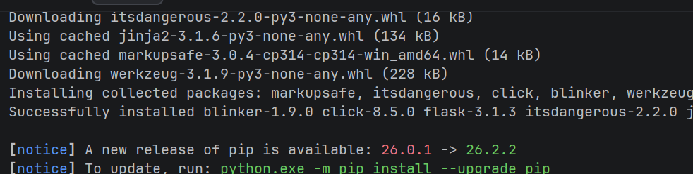
App.py :
from flask import Flask
app = Flask(__name__)
@app.route("/")
def home():
return "Student API Running"
if __name__ == "__main__":
app.run(debug=True)
terminal : python app.py
postman check :
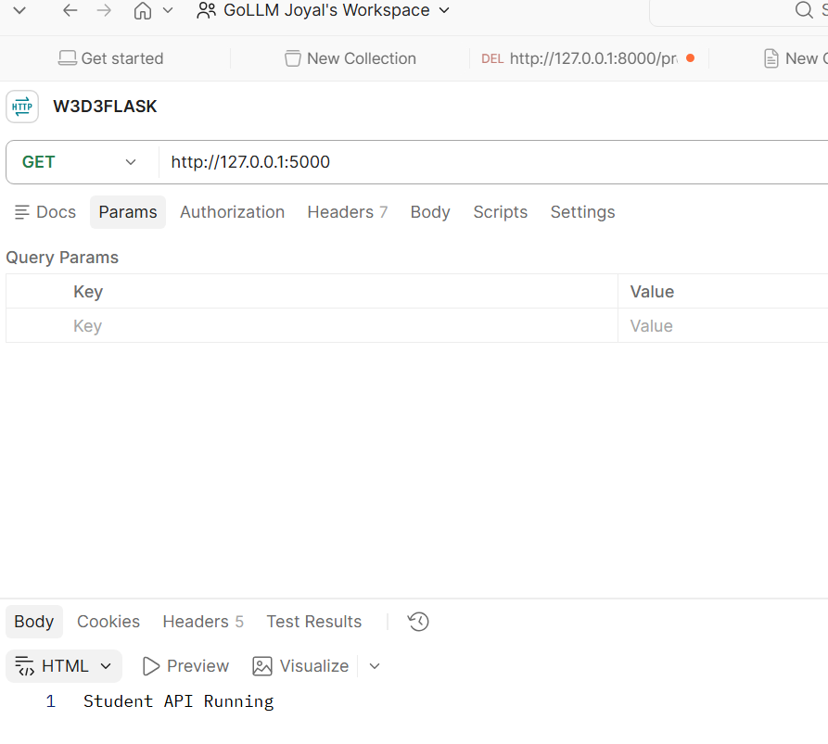
App.py: to insert data
from flask import Flask, jsonify, request
app = Flask(__name__)
students = [
{
"id": 1,
"name": "Rhea Kapoor",
"course": "Python",
"score": 82
},
{
"id": 2,
"name": "Zain Malik",
"course": "SQL",
"score": 76
},
{
"id": 3,
"name": "Devika Rao",
"course": "Cloud",
"score": 91
}
]

Tasks and solutions(python codes and postman screenshots):
1. GET all students
Create: GET /students. It should return all student records as JSON.
Code:
from flask import Flask, jsonify, request
app = Flask(__name__)
students = [
{
"id": 1,
"name": "Rhea Kapoor",
"course": "Python",
"score": 82
},
{
"id": 2,
"name": "Zain Malik",
"course": "SQL",
"score": 76
},
{
"id": 3,
"name": "Devika Rao",
"course": "Cloud",
"score": 91
}
]
@app.route("/")
def home():
return "Student API Running"
@app.route("/students", methods=["GET"])
def get_students():
return jsonify(students)
if __name__ == "__main__":
app.run(debug=True)
postman:
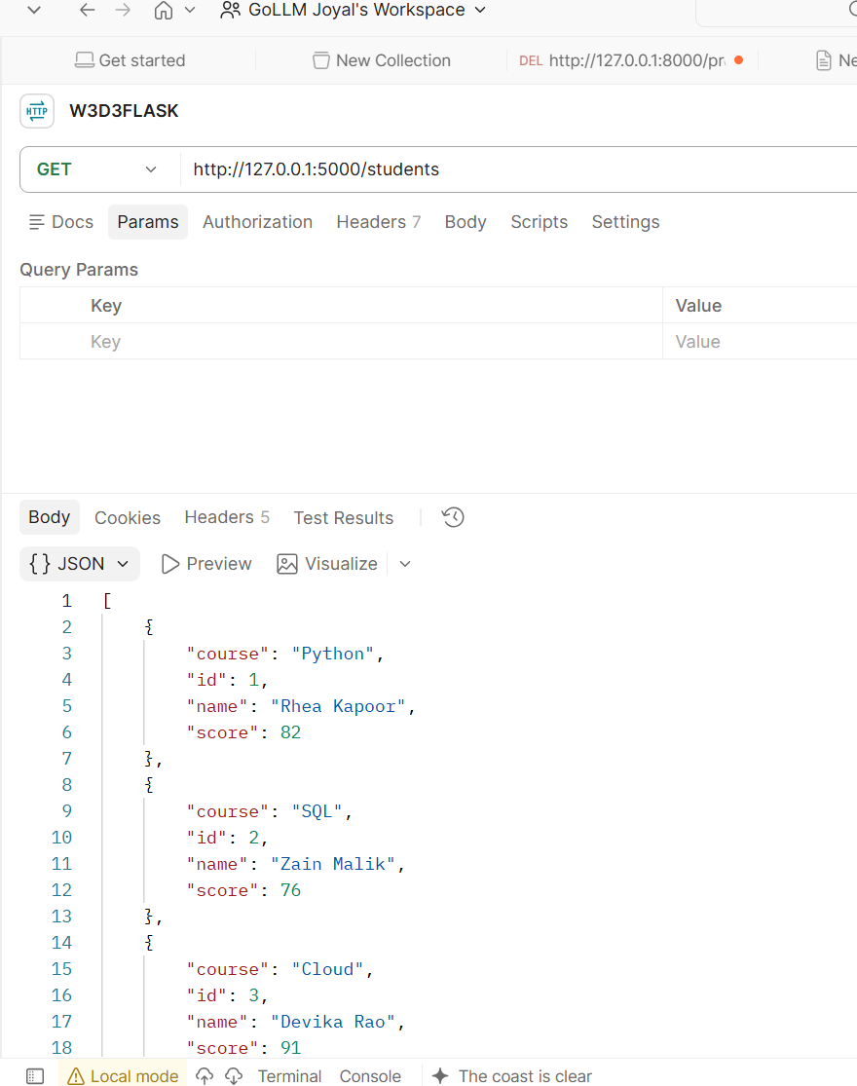
2. GET student by ID
Create: GET /students/<id>
Example:GET /students/2
Return the matching student.
If no student exists, return:
{
"message": "Student not found"
}
with status code 404 .
code:
@app.route("/students/<int:id>", methods=["GET"])
def get_student(id):
for student in students:
if student["id"] == id:
return jsonify(student)
return jsonify({
"message": "Student not found"
}), 404

postman:
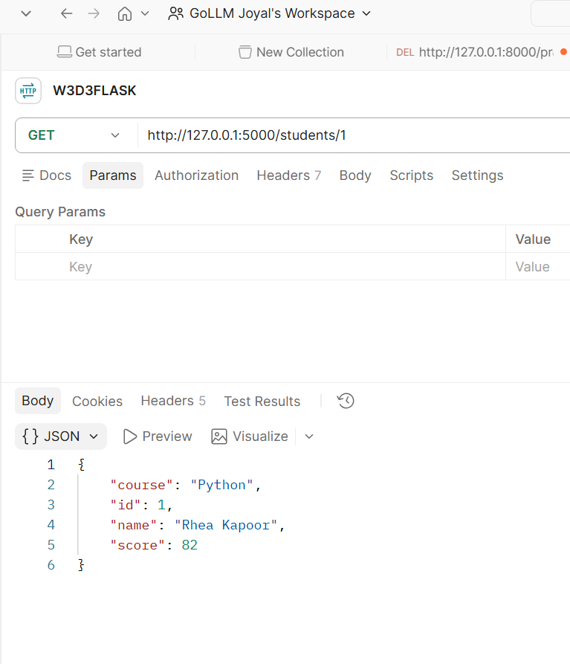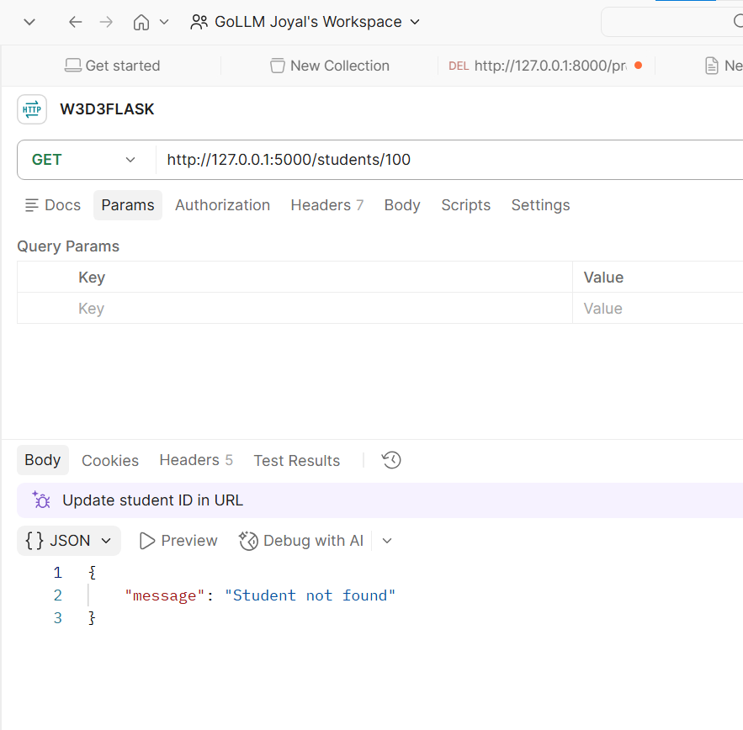
3. POST — Add a student
Create: POST /students. Request body example:
{
"id": 4,
"name": "Kabir Sen",
"course": "Docker",
"score": 88
}

Add the new student to the list.
Return:
{
"message": "Student added successfully"
}
Code:
@app.route("/students", methods=["POST"])
def add_student():
new_student = request.get_json()
students.append(new_student)
return jsonify({
"message": "Student added successfully"
}), 201

Postman:
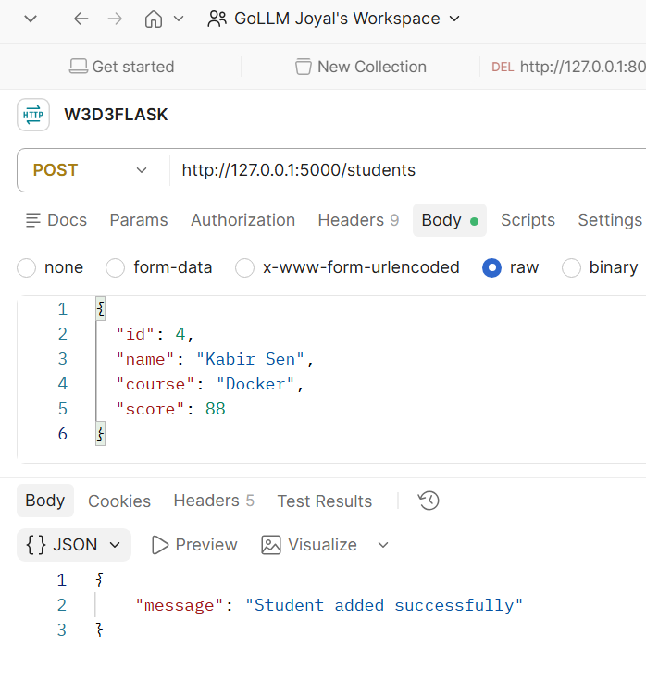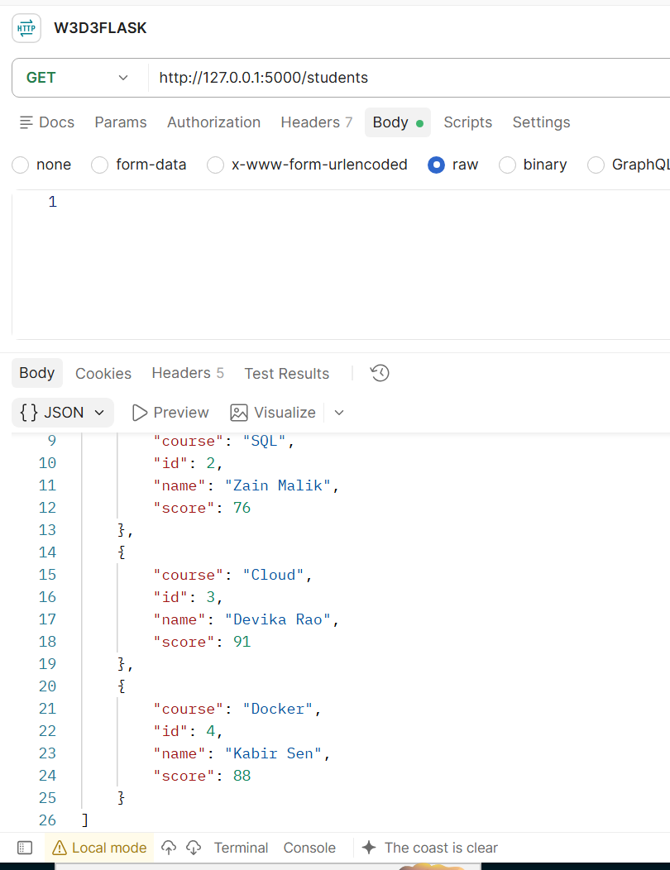

4. PUT — Update a student
Create:PUT /students/<id>
Example request:
{
"name": "Kabir Sen",
"course": "Docker",
"score": 93
}

Update the matching student.
Return:
{
"message": "Student updated successfully"
}

If the ID does not exist, return 404 .
Code:
@app.route("/students/<int:id>", methods=["PUT"])
def update_student(id):
updated_data = request.get_json()
for student in students:
if student["id"] == id:
student["name"] = updated_data["name"]
student["course"] = updated_data["course"]
student["score"] = updated_data["score"]
return jsonify({
"message": "Student updated successfully"
})
return jsonify({
"message": "Student not found"
}), 404

Postman:
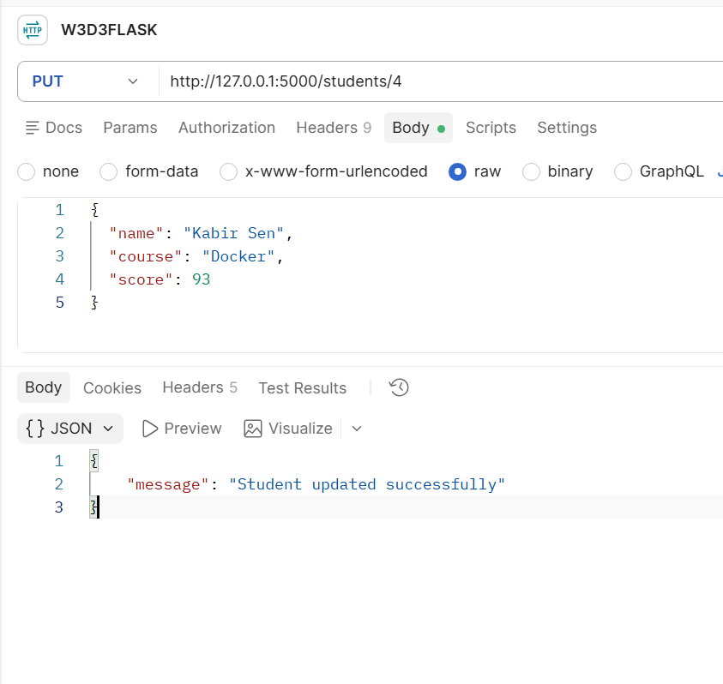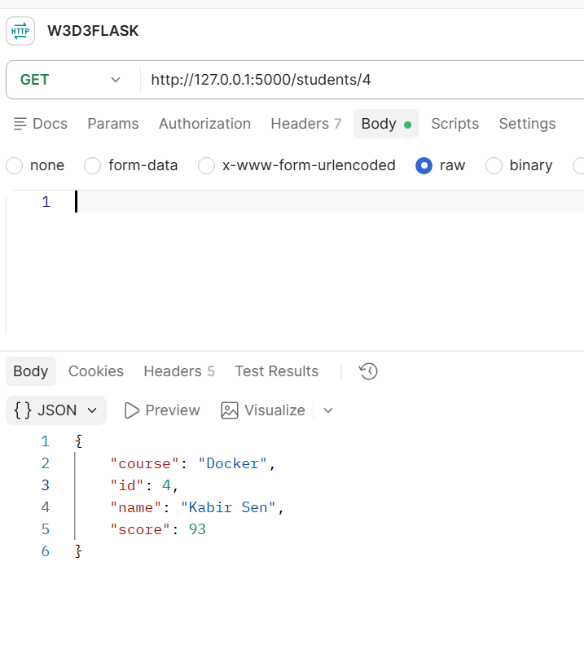

5. DELETE — Delete a student

Create: DELETE /students/<id>. Delete the matching student.
Return:
{
"message": "Student deleted successfully"
}
If no student exists, return 404 .

Code:
@app.route("/students/<int:id>", methods=["DELETE"])
def delete_student(id):
for student in students:
if student["id"] == id:
students.remove(student)
return jsonify({
"message": "Student deleted successfully"
})
return jsonify({
"message": "Student not found"
}), 404

Posytman:
